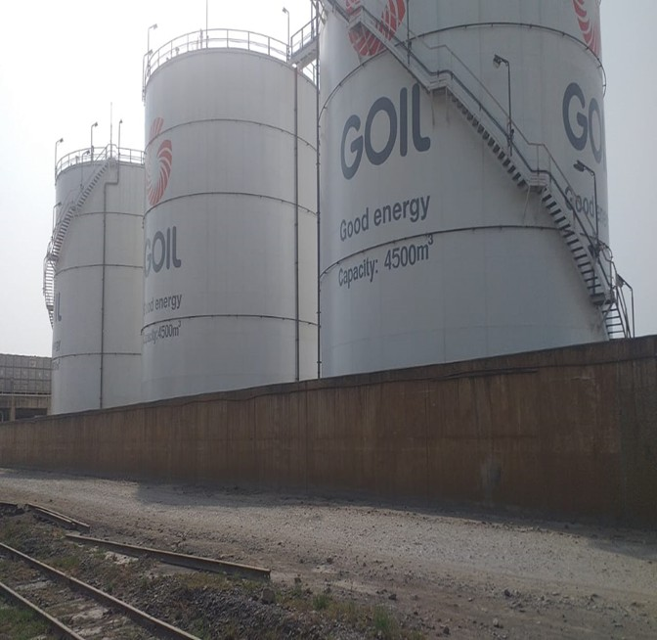
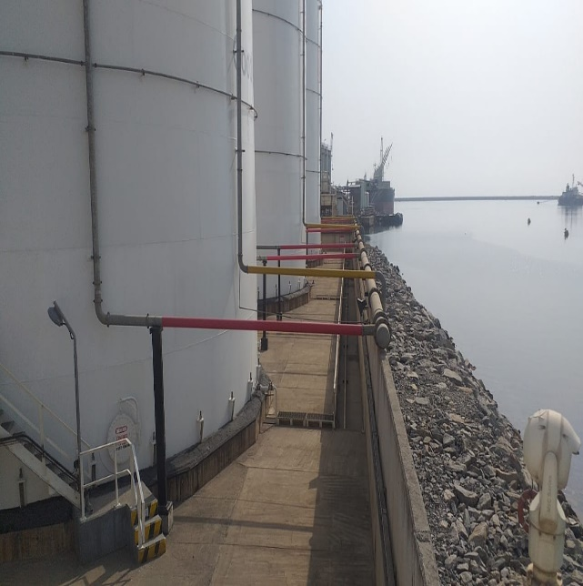


Annual Environmental Report
(2021)

Marine Gas Oil (MGO) Facility
(Quayside, Naval Base and Ship-to-Ship Bunkering)

FEBRUARY 2022

REPORT INFORMATION

Name of Company: GOIL Company Limited (GOIL)

Title of Document: Annual Environmental Report (AER) - 2021 for Bunkering

Areas of Operation: Offshore Takoradi Port and Onshore Naval Base

Validity Period: January - December 2021

Month and Year of Submission: January 2022

COMPANY INFORMATION

Registered Name of Undertaking: GOIL Company Limited (referred to as GOIL) Type of Undertaking: Offshore Bunkering and Onshore Petroleum Storage Depots Address for Correspondence: P.O. Box GP 3183, Accra
Telephone Number: Contact Person: Cyril Opon Position: Head of HSSE Location of Undertaking:
a. Onshore & Offshore Takoradi Port and Sekondi Naval Base b. District: Sekondi – Takoradi
c. Region: Western

Category of AER: 1st Annual Environmental Report (Under this permit) APPROVAL AUTHORITY: …………………………………………… SIGNATURE, STAMP & DATE: …………………………………………… NAME: ……………………………………………
DESIGNATION: ……………………………………………

[Annual Environmental Report (AER): 2021] Page i

TABLE OF CONTENT

1.0 INTRODUCTION .......................................................................................................................................... 2

1.1 COMPANY BACKGROUND .......................................................................................................................................2
1.2 LOCATION ...........................................................................................................................................................2
1.3 OPERATIONAL ACTIVITIES .......................................................................................................................................3
1.3.1 Onshore Bunkering ......................................................................................................................................3
1.3.2 Ship-to-Ship Bunkering ................................................................................................................................5

2.0. POLICY AND LEGAL FRAMEWORK GUIDING THE OPERATIONS AND ENVIRONMENTAL PROTECTION .......... 6

2.1 RELEVANT LAWS...................................................................................................................................................6
2.1.1 Environmental Protection Agency Act 1994, Act 490..................................................................................6
2.1.2 Environmental Assessment Regulations, (1999) LI 1652 .............................................................................7
2.1.3. The Fees and Charges (Amendment) Instrument, 2019, LI 2386 ............................................................7
2.1.4 Hazardous and Electronic Wastes Control and Management Act 2016(Act 917) .......................................7
2.1.5 Hazardous and other Waste (Classification), Control and Management Regulations 2016 LI2250 ...........8
2.1.6 Factories, Offices and Shops Act 1970, Act 328...........................................................................................8
2.1.7 The Labour Act 2003, Act 651 ....................................................................................................................9
2.1.8 Fire precaution (Premises) 2003, LI 1724 Regulations ................................................................................9
2.1.9 The Local Government Act 2016, Act 936 ...................................................................................................9
2.2.0 The Workman’s Compensation Law 1987, (PNDC 187).............................................................................10
2.2.1 National Petroleum Authority Act, 2005 (Act 691); ..................................................................................10
2.2.2 Ghana Maritime Authority Act, 2002 (Act 630); .......................................................................................10
2.2.4 National Oil Spill Contingency Plan 1986 (Revised 2010); .........................................................................11
2.2.5 International Convention for the Prevention of Pollution from Ships (MARPOL 73/78)............................11
2.3 ENVIRONMENTAL QUALITY STANDARDS ..................................................................................................................12
2.3.1 Ghana Standard for Environmental Protection – Requirement for Effluent Discharge (GS 1212.2019) ...12
2.3.2 Ghana Standard for Environmental Protection – Requirement for Ambient Noise Control (GS 1222.2019)
12
2.3.3 Ghana Standard for Environmental Protection – Requirement for Ambient Air Quality and Point Source
Stake Emissions (GS 1236.2019).............................................................................................................................13

3.0 MONITORING AND COMPLIANCE ..............................................................................................................14

3.1 ENVIRONMENTAL PERMIT (NUMBER: CE0048810132) ...........................................................................................14
3.2 ANNUAL MONITORING AND REPORTING .................................................................................................................14
3.3 OVERVIEW OF ENVIRONMENTAL MANAGEMENT PLAN (EMP) ....................................................................................14
3.4 OIL SPILL RESPONSE AND LEAKAGE MANAGEMENT ...................................................................................................15
3.4.1 GOIL Oil Spill Contingency Plan .................................................................................................................15
3.4.2 Safety Exclusion Zone ................................................................................................................................15
3.4.3 Oil Spill Response Planning........................................................................................................................15
3.4.4 Oil Spill Response Training ........................................................................................................................16
3.5 WASTE MANAGEMENT AND REDUCTION PRACTICES .................................................................................................16

4.0 CURRENT ENVIRONMENTAL MANAGEMENT PRACTICES ...........................................................................17

4.1 ENVIRONMENTAL MANAGEMENT PRACTICES ...........................................................................................................17
4.1.1 Operational Facility ...................................................................................................................................18
4.1.2 Gaseous Emissions Management..............................................................................................................18

4.1.3 Waste Management .................................................................................................................................19
4.1.4 Oil Spillage Management ..........................................................................................................................19

5.0 ENVIRONMENTAL PERFORMANCE ............................................................................................................21

5.1 OIL SPILLS AND LEAKAGES ....................................................................................................................................21
5.2 WASTE GENERATION...........................................................................................................................................21
5.3 AIR QUALITY MONITORING ..................................................................................................................................23
5.4 NOISE MONITORING RESULTS ...............................................................................................................................24
5.5 BUNKER TRADE VOLUMES ....................................................................................................................................24
5.6 RESOURCE USE ..................................................................................................................................................25
5.6.1 Water Use .................................................................................................................................................25
5.6.2 Own-Fuel Use ............................................................................................................................................25
5.6.3 Energy (Electricity) Use..............................................................................................................................25

6.0 RECORDED INCIDENTS ...............................................................................................................................27

7.0 CONCLUSION .............................................................................................................................................28

APPENDIX 1: ENVIRONMENTAL PERMIT.................................................................................................................29

List of Tables

TABLE 1: AMOUNTS AND TYPES OF WASTE GENERATED IN 2021 ...................................................................................................22

TABLE 2: AIR QUALITY MONITORING RESULTS ON JUNE 17 2021.................................................................................................23

TABLE 3: SHOWS THE NOISE MEASUREMENTS AT THE TAKORADI PORT AND NAVAL BASE ON JUNE 17 2021 .........................................24

TABLE 4: INFORMATION ON PRODUCT RECEIVED AND TRANSFERRED/SOLD .....................................................................................24

TABLE 5: SHOWS RESOURCE USE PATTERNS FOR 2021 ...............................................................................................................26

1.0 INTRODUCTION

This Annual Environmental Report has been compiled in accordance with the requirements of

Section 6.20 of EPA Environmental Permit No. CE0057180118, issued to GOIL on 22nd January

2021. The report contains a description of environmental monitoring activities conducted in the year

2021.

This Annual Environmental Report (AER) constitutes the company’s first reporting requirements to the Environmental Protection Agency under this permit. GOIL is a state-owned limited company incorporated under the Companies Code, 1963 [Act 179] duly licensed to deal in both Bulk Distribution and Marketing of Refined Petroleum Products with a Logistics and Support Service Subsidiary rendering services to Client across the entire country. The company also specializes in the supply of marine fuel and lubricants to vessels fleeting through the Gulf of Guinea.

1.1 Company Background

GOIL is a Ghanaian limited liability company licensed by the National Petroleum Authority (NPA) to provide services to the downstream Petroleum Industry (transportation, distribution, storage and bunkering) in Ghana. GOIL currently under this permit operates licensed offshore and onshore bunkering facilities to support its Marine Gas Oil (MGO) and lubricant operations. These facilities are located within the Takoradi Port and Sekondi Naval Base all in the Sekondi-Takoradi Metropolis of the Western Region.

1.2 Location

The operations of GOIL as already indicated covers the onshore petroleum depots facilities at the quayside of the Takoradi Port and the Sekondi Naval Base. This defined the following geographical coordinates.
a. Takoradi Port Facility (Quayside)

Coordinates | Latitude | Longitude
Coordinates | 4° 53¢ 16.1² N | 1° 44¢ 47.1² W

b. Sekondi Naval Base Facility

Coordinates | Latitude | Longitude
Start | 4.9408 | -1.7053
End | 4.9395 | -1.6983

c. The offshore bunkering operations are undertaken within the designated GPHA

bunkering area at the Takoradi Port with the following coordinates.

ZONE | NAME | BOUNDARY  POINTS | LAT. | LONG. | FUNCTION
D | ANCHORED STS | 1 | 05° 24’ 70N | 000° 21’ 00W | LARGE  TANKERS AND STS OPERATIONS AT ANCHOR
D | ANCHORED STS | P | 05° 31’ 80N | 000° 08’ 40E | LARGE  TANKERS AND STS OPERATIONS AT ANCHOR
D | ANCHORED STS | U | 05° 34’ 70N | 000° 17’ 40E | LARGE  TANKERS AND STS OPERATIONS AT ANCHOR
D | ANCHORED STS | M | 05° 21’ 20N | 000° 01’ 10W | LARGE  TANKERS AND STS OPERATIONS AT ANCHOR
E | DRIFT  ZONE | R | 05° 10’ 90N | 000° 14’ 90W | BUNKERING  AND STS OPERATIONS UNDERWAY
E | DRIFT  ZONE | U | 05° 34’ 70N | 000° 17’ 40E | BUNKERING  AND STS OPERATIONS UNDERWAY
E | DRIFT  ZONE | L | 05° 24’ 70N | 000° 24’ 90E | BUNKERING  AND STS OPERATIONS UNDERWAY
E | DRIFT  ZONE | S | 05° 00’ 30N | 000° 07’ 40W | BUNKERING  AND STS OPERATIONS UNDERWAY
G | ANCHORAG  E AREAS TANKERS, CAPESIZE AND STS | A | N4º 37.6ʹ | W001º57.8ʹ
G | ANCHORAG  E AREAS TANKERS, CAPESIZE AND STS | B | N4º 25.5ʹ | W001º57.8ʹ
G | ANCHORAG  E AREAS TANKERS, CAPESIZE AND STS | C | N4º 45.5ʹ | W001º14.0ʹ
G | ANCHORAG  E AREAS TANKERS, CAPESIZE AND STS | D | N4º 33.6ʹ | W001º14.0ʹ

1.3 Operational Activities

1.3.1 Onshore Bunkering

Currently, GOIL handles the distribution of marine gas oil to Clients in the territorial waters of Ghana. This activity by GOIL involves three (3) main bunkering operations operated by GOIL at the Quayside, Naval Base and Ship-to-Ship bunkering. The onshore bunkering operations takes place at the quayside of the Onshore Takoradi Port within the GPHA designated area and storage depots at the Sekondi Naval Base.

The fully automated transfer operations involve MGO being received through a jetty into storage tanks at the quayside of the Takoradi port terminal utilizing hoses and pipelines. Similar operations transfer MGO into storage tanks situated at the Sekondi Naval Base storage depot.

The facilities supporting the onshore bunkering activities of GOIL are presented in figures 1 &

2.

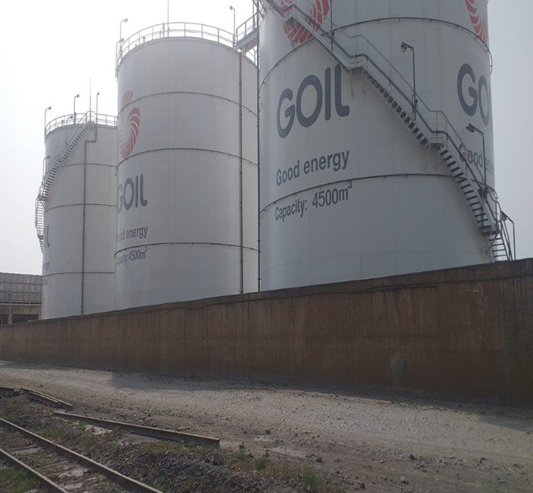
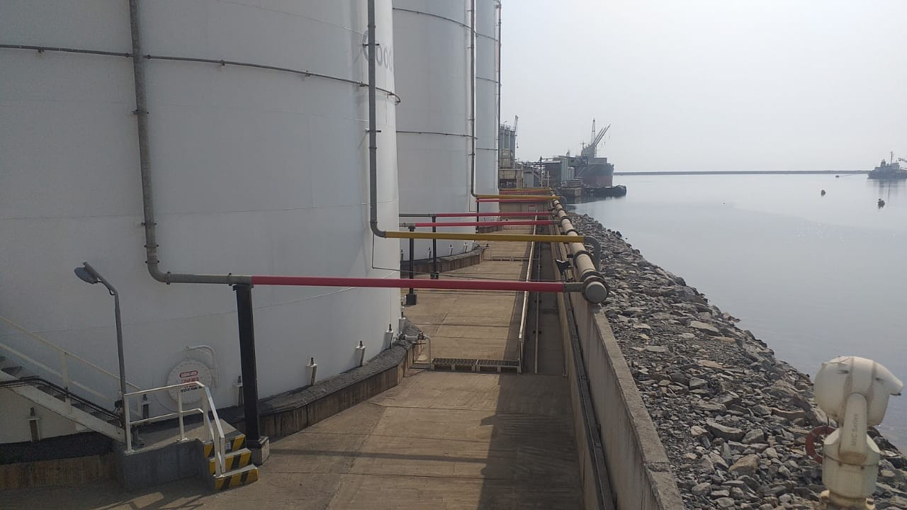
a. Quayside Depot

- 3No. 4,500m3 above ground Marine Gas Oil (MGO) storage tanks

- A 2,688m3 dike

Figure 1: Showing Quayside Surface Storage Tanks

b. Sekondi Naval Base

- 2No. 1,200,000 litre surface storage tanks

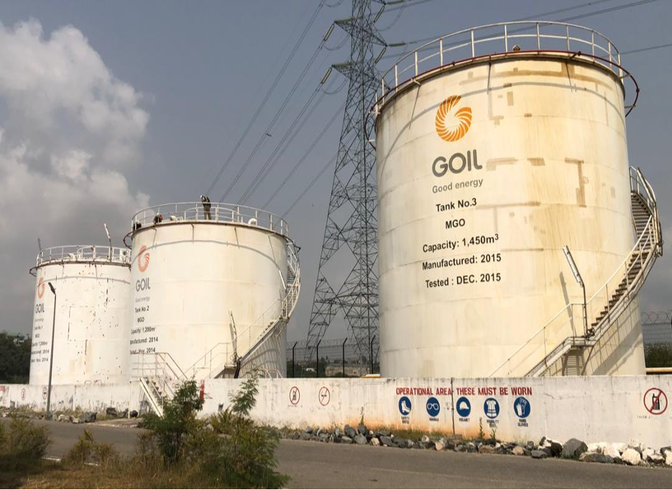
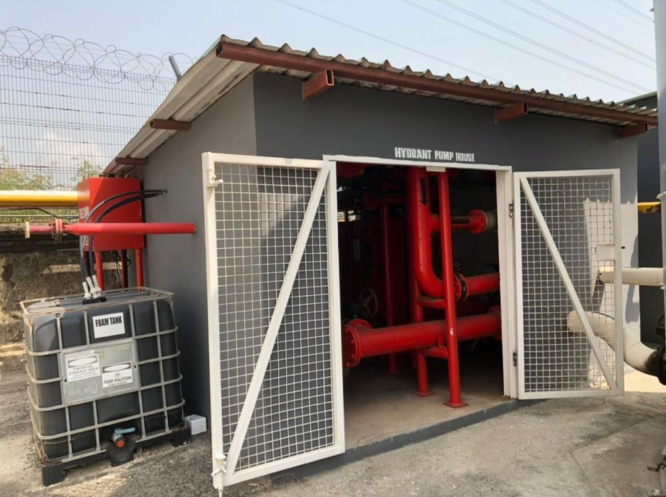
- 1No. 1,450,000 litre surface storage tanks

Figure 2: Showing Facilities at the Sekondi Naval Base

1.3.2 Ship-to-Ship Bunkering

The ship-to-ship bunkering operations is often called offshore bunkering and principally involve storage and dispensing of bunkers from the storage vessel to the client vessel through ship-to-ship transfers. There will also be the replenishing of stocks of the storage tanker with supplies from the onshore storage facilities at both the Takoradi Port and Naval Base respectively.

The operational area of the bunkering activities is within the official designated (Ship-to-Ship (STS) zones at Offshore Takoradi Port. The choice of the location has been informed by consultations with Ghana Ports and Harbours Authority (GPHA) as well as Ghana Maritime Authority (GMA). Careful consideration has therefore been given to all the relevant factors that would go into deciding whether the operational area should be relocated if the need arises.

The mother ship is fully equipped with the appropriate safety devices to ensure complete safety of the operations. The ship has been duly classed by Bureau Veritas and is manned by a competent crew. The ship complies to the requirements of MARPOL and has a Shipboard Marine Pollution Emergency Plan (SOPEP). The ship is an autonomous self-supporting unit with all necessary equipment and facilities to operate independently afloat. The bunkering operations is carried out whilst the vessels are at anchor. The vessel anchors are designed to hold the vessel in position and prevent it from drifting with the wind or sea currents thus enabling the operations to be carried out safely.

2.0. POLICY AND LEGAL FRAMEWORK GUIDING THE OPERATIONS AND ENVIRONMENTAL PROTECTION

2.1 Relevant Laws

The relevant environmental laws and regulations that guide GOIL Company Limited

(GOIL) during the project implementation and monitoring include the following:

• The Environmental Protection Agency Act, 1994, Act 490;

• Environmental Assessments Regulations, 1999, LI1652;

• The Fees and Charges (Amendment Instrument), 2015, LI 2228;

• Hazardous and Electronic Wastes Control and Management Act 2016(Act 917)

• Hazardous and other Waste (Classification), Control and Management Regulations 2016

LI2250

• Factories, Offices and Shops Act, 1970 (Act 328);

• The Labour Act 2003, Act 651

• Fire precaution (Premises) 2003, LI 1724 Regulations

• National Petroleum Authority Act, 2005 (Act 691);

• Ghana Maritime Authority Act, 2002 (Act 630);

• National Oil Spill Contingency Plan 1986 (Revised 2010);

• International Convention for the Prevention of Pollution from Ships (MARPOL 73/78)

2.1.1 Environmental Protection Agency Act 1994, Act 490

The Environmental Protection Agency (EPA) Act 1994 (Act 490) established and gives mandate to the Agency to ensure compliance of all investments and undertakings with laid down Environmental Assessment (EA) procedures in the planning and execution of development projects, including compliance in respect of existing ones. The EPA is the responsible for issuing environmental permits for operations such as this project subject to EPA review.

GOIL’s Obligation: This law is the primary legal basis for undertaking Environmental Management for Companies in Ghana. GOIL shall fully comply with requirements of this national regulation in the performance of their activities.

2.1.2 Environmental Assessment Regulations, (1999) LI 1652

The Environmental Assessment Regulations 1999 (LI 1652) enjoins any proponent or person to register an undertaking with the Agency and obtain an Environmental Permit prior to commencement of the project.

This regulation allows the EPA to place proposed undertakings at the appropriate level of environmental assessment. The Legislative Instrument prescribes the procedure for conducting an Environmental Impact Assessment in Ghana. The LI 1652 seeks to ensure that development is undertaken in a sustainable environment.

GOIL’s Obligation: GOIL is required under this regulation to prepare their Annual reports;

this is therefore being prepared in compliance with the above provision.

2.1.3. The Fees and Charges (Amendment) Instrument, 2019, LI 2386

The Fees and Charges (Amendment) Instrument, 2019 (LI 2386) gives regulation to the fees and charges (Miscellaneous Provision) Act 2009, Act 793. The law provides a comprehensive rates, fees and charges collectable by Ministries, Department and Agencies (MDAs) for goods and services delivered to the public.

GOIL’s Obligation: This law helps the company to be abreast with the fees and charges to be paid to EPA

2.1.4 Hazardous and Electronic Wastes Control and Management Act 2016(Act 917)

This LI ensures that harmful elements associated with hazardous and other waste products are captured and processed safely to preserve critical ecological components such as the soil, ground water, flora and fauna.

GOIL’s Obligation: The Act is important to the company since some hazardous waste would be handled and managed better. GOIL will comply fully with the provisions in this Act.

2.1.5 Hazardous and other Waste (Classification), Control and Management Regulations

2016 LI2250

This legislative instrument spells out clearly the appropriate and relevant regulations guiding the implementation of the Hazardous and Electronic Wastes Control and Management Act 2016, (Act 917).
Specific sections of this LI relevant for this project include the following:

a) Section 3 of the LI 2250 requires all facilities which generate waste to classify their waste in accordance with the second schedule of the LI2250
b) Section 11 and 12 of LI2250 requires the applicant to keep up to date records and keep a waste manifest system respectively.

GOIL’s Obligation: This Act is important to the company because it will help them to handle and manage hazardous waste better. GOIL shall comply with the provisions of this LI 2250. This Act is significant to the company since hazardous waste could be handled and managed better. GOIL shall fully comply with the provisions in LI 2250 through its sound management of hazardous waste.

2.1.6 Factories, Offices and Shops Act 1970, Act 328

The Factories, Offices and Shop regulates the conditions of employment in factories and other places of work as regard to the safety, health and welfare of persons employed there in. The Act also provides for examination and inspection of certain plant and machinery in order to ensure safety.

GOIL’s Obligation: This Act is relevant to the company due to the fact that the factories operational activities would require workers to be provided with personal protective equipment and their general wellbeing as provided for in the Act. GOIL shall comply with the provisions of the Act in order to safeguard the workers.

2.1.7 The Labour Act 2003, Act 651

Section 118(1) of the Labour Act 2003 (Act 651) stipulates that it is the duty of an employer to ensure that every worker employed works under satisfactory, safe and healthy conditions.

GOIL’s Obligation: The Company will employ people and therefore will apply this Act. GOIL shall ensure that labour wages, salaries and other related issues specified in the law are adhered to.

2.1.8 Fire precaution (Premises) 2003, LI 1724 Regulations

The fire Precaution regulations 2003 LI 1724 was passed to give backing to the Ghana National Fire Service (GNFS) to insist on or evaluate Fire Safety Precautions measures in premises to occupants or any other person staying in that premises by ensuring that they can escape from fire safely and quickly.

GOIL’s Obligation: This regulation is important to the project because it will ensure that fire safety measures are put in place to protect lives that will use the premises as well as the properties in the facility. GOIL will comply with this regulation by the National Fire Service.

2.1.9 The Local Government Act 2016, Act 936

Act 462 established the District Assemblies as the District planning and administrative authority. The Act makes the District Assemblies (DAs) the highest political authority in each district. Typically, the Assemblies have a total of 70 members, roughly 70 percent of whom are elected and 30 percent is appointed. Assembly members are responsible for deliberation, evaluation, coordination, and implementation of programs accepted and appropriate for the district’s economic development.

The Act provides that no physical development can be undertaken within the Districts without approval from the District Authorities. The District Assemblies have the responsibility to ensure that developments conform to the district planning schemes. The project will therefore consult with the relevant District Assembly to obtain any concerns that they might have

regarding the project.

GOIL’s Obligation: It is relevant because the Project site is under the jurisdiction of the local authority of Sekondi Takoradi Metropolitan Assembly. GOIL will comply with all the relevant provisions of the Act.

2.2.0 The Workman’s Compensation Law 1987, (PNDC 187)

The law holds employers responsible for the payment of compensation to workmen for personal injuries caused by accidents arising out and in the course of their employment.

GOIL’s Obligation: The Company’s management of occupational hazards (risks) among workers on the construction and operation of the facility will be based on this Act. GOIL will comply with this regulation by ensuring the company develops an occupational Health and Safe standards which will be strictly enforced.

2.2.1 National Petroleum Authority Act, 2005 (Act 691);

The act is to regulate, oversee and monitor activities in the Petroleum downstream industry and where applicable do so in pursuance of the prescribed petroleum pricing formula.

GOIL’s Obligation: The Company’s petroleum pricing formula is in compliance with this act and ensures it activities downstream is in accordance with the law.

2.2.2 Ghana Maritime Authority Act, 2002 (Act 630);

The Ghana Maritime Authority (GMA) Act 2002, Act 630 has been enacted establishing the Ghana Maritime Authority which will advise Government on maritime matters and assist the Ministry of Transport (MOT) to formulate policies, monitor, regulate and coordinate activities and programmes of the various sub-sectors in the maritime industry.

GMA is mandated to ensure the safety of navigation, fulfil flag state and port state responsibilities in an effective and efficient manner, regulate the activities of the shipping in the inland waterways including safety of navigation in inland waterways. The Authority is the main body for national planning purposes in relation to the maritime sector. It is thus to ensure an efficient, cost effective and orderly provision of services in the shipping industry in line with Government policies and regulate the activities of shipping agents, freight forwarders and similar shipping service providers.

GOIL’s Obligation: This regulation is important to the project because it will ensure the safety of navigation and also regulate the shipping activities of GOIL at the Takoradi Port. GOIL will comply with this regulation by the Ghana Maritime Authority.

2.2.4 National Oil Spill Contingency Plan 1986 (Revised 2010);

This plan aims to outline the national arrangements for responding to oil spill in the marine environment with the aim of protecting it from oil pollution or, where this is not possible, to minimise its effects. The plan delineates responsibilities for the preparation and operational response to incidents, which could or result in spillage of oil into the marine as well as the coastal environment of the Republic of Ghana.

GOIL’s Obligation: The management of GOIL will ensure that this plan is strictly adhered to by the company.
2.2.5 International Convention for the Prevention of Pollution from Ships (MARPOL 73/78) The Convention includes regulations aimed at preventing and minimizing pollution from ships

both accidental pollution and that from routine operations - and currently includes six technical

Annexes. Special Areas with strict controls on operational discharges are as follows:

• Regulations for the Prevention of Pollution by Oil (1983)

• Regulations for the Control of Pollution by Noxious Liquid Substances in Bulk (1983)

• Prevention of Pollution by Harmful Substances Carried by Sea in Packaged Form (1992)

• Prevention of Pollution by Sewage from Ships (2003)

• Prevention of Pollution by Garbage from Ships (1988)

• Prevention of Air Pollution from Ships (2005)

GOIL’s Obligation: Management of GOIL will ensure prevention of marine pollution from waste generated by their marine vessels.
2.3 Environmental Quality Standards

The standards provide permissible levels for ambient air quality, noise levels and effluent quality before discharge into natural water bodies.

2.3.1 Ghana Standard for Environmental Protection – Requirement for Effluent Discharge

(GS 1212.2019)

The standard for effluent discharge sets the permissible levels of discharge for every facility in the various sectors. GS 1212:2019 sets out the requirements for pollution control to ensure that treated effluent discharges are detoxified using the best available technology to meet the recommended levels. It provides recommendations for the sampling and preservation of effluent discharges. It provides guidelines on prohibitive actions that must be avoided by the facilities if such actions would alter effluent discharge quality without notifying the regulator.

GOIL’s Obligation: Management of GOIL will ensure their operations comply with the permissible levels for Effluent Quality Discharge.

2.3.2 Ghana Standard for Environmental Protection – Requirement for Ambient Noise

Control (GS 1222.2019)

The standard for ambient noise control provides the requirements of the Ghana standard for acceptable ambient noise levels within categorized locations. The category of locations is broken down into Zones from A through G, and that is from residential to heavy industrial areas. The day-time permissible noise levels range from 55 dB for Zone A to 70 dB for Zone G, while the night-time levels range from 48 dB to 70 dB for Zone A and G respectively.

The standard further provides the requirements for monitoring returns on ambient noise levels and the requirements for conformance. The standard provides the testing protocols to be used for the monitoring of ambient noise.

GOIL’s Obligation: Management of GOIL will ensure their operations comply with the permissible levels for Noise Control.

2.3.3 Ghana Standard for Environmental Protection – Requirement for Ambient Air Quality and Point Source Stake Emissions (GS 1236.2019)

GA 1236:2019 is the standard that specifies the requirements and test methods needed for ambient air quality and point source/stack emissions. The requirement for testing is based on the source of energy. The requirements include the levels permissible for specific contaminants over certain durations. It sets out the requirements for monitoring returns and the need for compliance.

GOIL’s Obligation: Management of GOIL will ensure their operations comply with the permissible levels for Ambient Air Quality and Point Source Stake Emissions.


3.0 MONITORING AND COMPLIANCE

3.1 Environmental Permit (Number: CE0048810132)

Based on satisfactory fulfillment of requirements, the EPA issued GOIL Company Limited (GOIL) with a new environmental permit (Ref: Permit Number: CE0057180118) for the onshore and Ship-to- Ship Bunkering on 22nd January, 2021. This permit is attached as Appendix 1 of this report.

3.2 Annual Monitoring and Reporting

As required by EPA Permit No. CE0057180118, GOIL is submitting its first annual environmental monitoring reports to the EPA for the year 2021. This report provides information about the environmental impacts of operations, resources consumed, amounts of waste generated, incidents that were recorded, and training activities conducted during the year. This information is also presented graphically in the reports for easy interpretation and appreciation of trends, where possible.

3.3 Overview of Environmental Management Plan (EMP)

The GOIL EMP sets out the overarching framework of environmental management principles that are applied to operations. A brief description of the components of the EMP can be seen below:

• Environmental Monitoring Plan – measure to ensure regulatory compliance, measure the effectiveness of proposed mitigation, continue baseline monitoring, and review environmental and social performance;

• Waste Management Plan – measures to ensure that waste generated is minimized, stored, transported and disposed of in accordance with regulatory requirements;

• Resource Conservation Plan – measures to ensure efficient use of resources such as water, fuel, and electricity;

• Marine environment Conservation – measures to minimize the negative impacts of our operational activities on the marine environment and the natural environment, to prevent pollution and contamination of the water.

• Training and Capacity Building – training and capacity shall be provided in all aspects of the

EMP.

3.4 Oil Spill Response and Leakage Management

3.4.1 GOIL Oil Spill Contingency Plan

In accordance with its obligations to the EPA, GOIL has developed an Oil Spill Contingency Plan (OSCP) and submitted a copy to the EPA. The OSCP includes a description of the structure of the Emergency Management Team and strategies and guidelines for responding to onshore and offshore oil spills.

3.4.2 Safety Exclusion Zone

The ship-to-ship transfer operations are located within a marine safety exclusion zone, delineated specifically to prevent unauthorized excursions into the area. The Safety Exclusion Zone is clearly designated in the STS Zone offshore Takoradi Port.

3.4.3 Oil Spill Response Planning

GOIL has developed a Tier 1 oil spill response capability. This is implemented by the use of its robust oil spill contingency plan (OSCP) backed by equipment resources to respond to offshore and onshore oil spills. GOIL’s oil spill response resources are stored in strategic locations such as the Sekondi Naval Base to ensure quick and effective deployment in case of emergency.

3.4.4 Oil Spill Response Training

GOIL could not conduct training for its emergency responders due to travel restrictions of the trainers as a result of the COVID-19 pandemic. The training has been postponed to the first quarter of 2022. Stakeholders, including the EPA, will be invited to participate in the training when GOIL agree on a date.

3.5 Waste Management and Reduction Practices

GOIL has developed waste segregation procedure for managing and reducing waste. Dustbins are labeled with color codes to help in waste segregation. The core element of this waste segregation procedure is to ensure that employees and external contractors are trained to properly segregate waste for recycle, reuse, recovery and disposal. Cross-contamination of waste are always avoided. As an example, if hazardous waste such as oily sludge comes into contact with recyclable waste, the entire waste load becomes contaminated and must be treated as hazardous.

In line with its commitment to environmental protection, GOIL continued to ensure prudent management of waste streams from its operations in 2021. As no significant changes occurred in operations, new forms of waste were not produced. Thus, waste management efforts focused on reduction, containment, and safe disposal.

4.0 CURRENT ENVIRONMENTAL MANAGEMENT PRACTICES

4.1 Environmental Management Practices

This section provides the context of the environmental performance and examines the current practices of GOIL’s HSE policy and best industry practices. Key objectives of the policy are;

• Compliance with all safety and environmental laws and regulations;

• Emergency preparedness and response;

• Minimize wastes streams and emissions;

• Ensure the implementation of a system that is monitored at all times with the aim of continual improvement.

The environmental management practices are monitored for compliance and audited in accordance with GOIL’s HSSE policy. Essentially, GOIL conducts its operations with the intent of reducing to a minimum, all adverse impacts associated with the operation of the onshore and ship-to-ship activities for the transfer of petroleum products from vessels onshore via onshore pipelines to various tank farm facilities while taking steps to ensure the safety of staff and the general public.

The current environmental management performance of the company is addressed under the following;

• Operational facilities

• Gaseous emissions management

• Water quality

• Occupational Health and Safety

• Waste management

• Oil spill prevention and management

• Fire prevention and management

• Utilities/Energy management

4.1.1 Operational Facility

The conditions of all the onshore installations remain central to the optimum operation of the bunkering facility. In this regard, all these facilities are well maintained to protect them from corrosion, leaks and failures. Routine preventive maintenance works and regular inspections are carried out to ensure the facilities operate in a relatively safe manner, providing for the preservation of property and the environment. These maintenance activities are compatible with local environment and operational conditions. Maintenance activities involve cleaning of meter strainers, greasing of valves, servicing of pumps, control valves, pumps switches. Weekly checks are carried out to ensure pipeline, hose integrity and optimum rope performance and extended life. The maintenance procedures and activities are routinely updated to enable onshore operators to predict the life expectancy of equipment and allow equipment and parts to be retired on scheduled basis.

4.1.2 Gaseous Emissions Management

Gaseous emissions of hydrocarbon vapours (VOCs) are expected to be released during petroleum offloading or discharging. VOCs can also be released in the event of hose damage and/or leakage. However, GOIL has adopted and implemented offloading practices and routine preventive maintenance programs that minimize VOC emissions into the ambient environment. In addition, the vessel and associated fluid transfer systems are fitted with camlock fittings to prevent escape of VOC vapors into the atmosphere during discharge. It should be noted that the vast sea expanse and the strong onshore breeze helps in prompt dispersal of any VOCs that may escape thus VOCs concentrations within the discharging area. Personal prospective equipment (PPE) including Fire Retardant Clothing (overalls) and respirators that protects personnel from skin contact with hydrocarbons and respirators that protect VOC inhalation have been provided.

The extent of ambient air quality monitoring at various locations (bunkering and Office areas) at is sufficient to demonstrate full compliance with the applicable EPA regulations. The air quality monitoring is conducted at the facilities for parameters such as VOCs, SO2, NO2, CO, TSP and PM10

as part of ensuring regulatory compliance. The monitoring and reporting program as part of the air quality management include regular audits and reviews.

4.1.3 Waste Management

Waste generated from the operations of GOIL includes general waste from the administrative offices and waste from the cleaning of the connecting hoses that transfer the petroleum products to and from the onshore vessels to other facilities. GOIL ensures the waste generation is minimized to the extent possible. GOIL ensures that all general waste at the facility are dumped into allocated waste bins and skips on site. The waste bins are regularly emptied by a certified domestic contractor, bi-weekly. Waste generated as a result of petroleum operations and slops are collected by a certified company for appropriate disposal. Liquid waste such as waste oil generated from the operations as well as barge and other support vessels are collected and handled by a contractor with the expertise in handling hazardous liquid.

4.1.4 Oil Spillage Management

Oil spill prevention is one of the prime objectives of GOIL’s hierarchy of controls. An oil spill contingency plan which includes an oil spill risk assessment, a prevention plan and an emergency response plan have been put in place and strictly adhered to, in order to avoid the incidence of oil spills, and in the event that it occurs, respond appropriately. Storage tanks are pressure tested to detect leakages. The tanks have a 2.6m high bounded walls made of re-enforced concrete to ensure that any leakage that may occur is contained and cleaned up as quickly as possible. There is an oil interceptor with an outlet valve also on site to ensure that spills when they occur from tanks or loading gantry is effectively contained.

Personnel manning the control valves during discharge are on radio contact with the Terminal Manager and the Environmental Health and safety Coordinator so that in the occurrence of a spill they can report it to the appropriate authority responsible to respond quickly in order to reduce the impact of the spill on the environment. The first priority of GOIL management in the occurrence of a spill is to contain

the spill while putting in measures to stanch the spill. The Terminal Manager at this point takes up the responsibility of ensuring the cleaning up of the spill to prevent possible pollution of the environment and also reduce economic losses.

GOIL also ensures the use of well-maintained vessels and bunkering infrastructure that meets international maritime organization’s design for safety and maintenance standards. Staff training is done annually to ensure the highest standards of HSSE and update employees on current best industry practices. The implemented measures had ensured a zero incidence of oil spillage in the past years.

5.0 ENVIRONMENTAL PERFORMANCE

This section provides the context of the environmental performance after examining the current practices of GOIL’s.

5.1 Oil Spills and Leakages

GOIL’s oil spill response plan is activated to contain any event of oil spill, and deploy the appropriate equipment to combat oil spills and leakages. The stock of response equipment includes skimmers, barriers, sand buckets, absorbent pads and cotton rags, booms, etc. Leakages and spills are minimized or prevented through periodic integrity checks on equipment and rectifying all the defects during operations.

In the year under review (2021), GOIL recorded NO oil spills incidents. There are however observations of minor spills which are considered as operational spills and responded to using tier 1 equipment on site.

5.2 Waste Generation

GOIL follows a waste classification procedure to guide the disposal of specific waste streams which are generated as part of its operations. The application of the classification procedure is done on individual waste streams and according to the description of the waste. Where a waste stream is asterisked, it is likely to be hazardous, although this will depend on the exact composition of the material. Any waste, such as oil filters, waste paper and wood packing are disposed of in accordance with best practice, and GOIL ensures that all contractors are made fully aware of their environmental responsibility toward waste management.

The classification of waste categorized the waste stream from GOIL’s operations into domestic/general waste, hazardous waste and other waste that is generally classified as non-hazardous. Solid domestic/general waste are generated mainly from the offices and gathered into bins placed on site for disposal by a private waste contractor. The management of liquid waste mainly from the washrooms are directed into septic tanks, which are dislodged periodically by a private waste contractor.

There is another category of waste that is non-hazardous such as tyres, scraps, etc generated on during occasionally during maintenance. The management of these materials are done through the waste management principles and disposal by waste management contractors. The third and final category of waste are waste classified as hazardous including contaminated or oily rags, waste oils, etc. Waste oil for instance is directly collected or through oil/water separated stored in drums in a bunded area and sent for recycling and disposal by third-party contractors. The amounts and types of waste generated from operations in 2021 are presented in Table 1.

Table 1: Amounts and types of waste generated in 2021

Site | Waste | Type | Classification | Source of  Generation | Quantity  (kg) | Disposal
Quayside  Takoradi Port | Garbage, scrap  metal, paper, plastics | Solid | Non-  hazardous | Offices | 2,480 | STMA  approved collector
Naval Base | Garbage, scrap  metal, paper, plastics | Solid | Non-  hazardous | Offices | 2,041 | STMA  approved collector
Quayside  Takoradi Port | Waste oil, used  filters, sludge, paints & solvents, oily rags | Solid &  Liquid | Hazardous | Mechanical  workshop, tank farm area | 11,061 | STMA  approved collector
Naval Base | Waste oil, used  filters, paints & solvents, sludge, oily rags | Solid &  Liquid | Hazardous | Mechanical  workshop, tank farm area | 1,304 | STMA  approved collector

5.3 Air Quality Monitoring

The nature of activities undertaken by GOIL, there are few sources of emissions coming from the operations. The major point source emissions come from the combustion of fuel to support bunkering operation, generators and vehicles. However, these emissions are low due to implementation of effective management practices including routine preventive maintenance, program. Limits established by the Ghana EPA for Air Quality are applicable for these sources.

Table 2 shows the results of ambient air quality monitoring results taken in June 17 2021. The data was collected over a period of 24 hours. The results show that all the monitoring results are within the EPA standards.

Table 2: Air Quality Monitoring Results on June 17 2021

LOCATION | TSP/  µgm3 | PM10/  µgm3 | PM2.5/  µgm3 | NOX | SOX | HC
Takoradi Harbour |  | 48.61 | 30.55 | 7.56
Secondi Naval Base |  | 55.56 | 31.94 | 1.84
EPA Standard  Values | 230 | 70 | - | 150 | 150 | -

GOIL excluded VOC emission measurements from the parameters monitored, as very robust systems are in place to minimize fugitive emissions. The inspections and maintenance program in place prevent loss of containment incidents which lead to the release of VOCs into the environment.

5.4 Noise Monitoring Results

Significant sources of noise generated from the operation of vehicles, generators and onshore operations are possible sources of noise. Potential impacts to the acoustic environment from GOIL’s operations include environmental noise disturbance and vibration-induced human discomfort. Noise levels from onshore operations are therefore controlled by regular servicing of all machinery and strict adherence to standard operating procedures. Generally, noise measurements indicate compliance with the EPA permissible limit of 70dBA for heavy industrial areas.

Table 3: shows the noise measurements at the Takoradi Port and Naval Base on June 17 2021

SITE | LAeq  VALUES | LA10  VALUES | LA50  VALUE S | LA90  VALUES | LAmax  VALUE S | STANDARD  VALUES  dB(A)
 |  |  |  |  |  | EPA | OHSA
Takoradi  Harbour | 50.5 | 56.9 | 53.9 | 52.4 | 65.9 | 70 | 97
Sekondi Naval  Base | 49.9 | 50.5 | 48.8 | 47.7 | 65.3 | 70 | 97

5.5 Bunker Trade Volumes

The main petroleum product transferred/ handled for the year under review is Marine Gas Oil. The annual product received and sold at the Takoradi Habour was 16,386,550 litres and 16,692,510 litres respectively. The received and sales volumes for the Sekondi Naval Base recorded under the reporting year was
11,620,303 litres and 10,217,840 litres respectively.

Table 4: Information on Product Received and Transferred/Sold

Site | Product Received (Litres) | Product Sold. (Litres)
Takoradi Harbour | 16,386,550 | 16,692,510
Sekondi Naval Base | 11,620,303 | 10,217,840

5.6 Resource Use

Energy supply to the bunkering vessels is from diesel-powered generators which are installed on-board to provide energy and heat to support the bunkering operations. However, the source of electric power for the office building and other onshore activities are from the Electricity Corporation of Ghana (ECG) as well as a standby generator. The utilities used at operational areas are in the form of water, electricity, and own fuel-use have also been recorded and presented in Tables 5.

5.6.1 Water Use

GOIL's source of water supporting its bunkering operations is from treatment water on-board the vessel. However, the water required for domestic use is supplied by the Ghana Water Company Limited. Records of water consumption at onshore Takoradi Port and Sekondi Naval Base showed average monthly consumption of 121.5 and 105.5 litres respectively in 2021.

5.6.2 Own-Fuel Use

GOIL utilizes fuel to operate its bunkering activities at both the Takoradi Port and Sekondi Naval Base respectively. The amounts of fuel consumed, however, is commensurate to the increase throughput for any particular reporting year. GOIL for the year under review consumed 1,230 litres and 870 litres of fuel at the Takoradi Port and Sekondi Naval Base respectively.

5.6.3 Energy (Electricity) Use

GOIL energy (electricity) consumption in support of its operations were mainly at the Takoradi Ports and Sekondi Naval Base. There is no data for the ship-to-ship bunkering operations as their activity are entirely offshore and independent of the national grid. On average, GOIL consumed 83,605.4 kWh and
23,753.4 kWh at both Takoradi Ports and Sekondi Naval Base respectively.

The summary of GOIL’s resource use patterns for the year under review is presented in table 5.

Table 5: Shows Resource Use Patterns for 2021

Site | Water Consumed (Litres) | Energy Consumed  (kWh) | Own Fuel Use. (Litres)
Takoradi Harbour | 121.5 | 83,605.4 | 1,230
Sekondi Naval Base | 105.3 | 23,753.4 | 870

6.0 RECORDED INCIDENTS

No environmental incidents occurred as a result of our operations within the year 2021. This is due to management commitment to developing a strong HSSE culture within GOIL and the special attention given to the identification, prevention and management of risk.

GOIL will continually review risk and introduce additional controls as well as risk mitigation measures necessary to protect health and safety and the environment.

GOIL will provide all necessary training and resources to employees and contractors to ensure that they can perform their roles and responsibilities safely and in an environmentally responsible manner.

Env. Permit No. CE0057180118

7.0 CONCLUSION

GOIL has had a very challenging but positive year (2021). GOIL continues to work on improving on their operations and work on reducing the environmental impacts of their operations.

GOIL is also working on reducing the consumption of resources, such as water, fuel and electricity; reduce its waste and emissions as well. To adhere to its environmental objective of serving its customers in an environmentally friendly environment, GOIL was challenged to ensure that the environmental impacts of its operations were not merely commensurate with the increase in throughput but even much lower.

These efforts accounted for the commendable environmental performance achieved in 2021. Since demand might most likely increase again driving an upturn in throughput for 2022, GOIL will be under even a lot more pressure to reduce impacts on the environment.

To meet this challenge, GOIL is evaluating a variety of strategies to reduce environmental impacts of its operations.
Information about the strategies that will be implemented and their resulting impacts will be provided in the Environmental Management Plan to the EPA in 2023.

[Annual Environmental Report (AER): 2021] Page 28

APPENDIX 1: ENVIRONMENTAL PERMIT
Env. Permit No. CE0057180118

_

[Annual Environmental Report (AER): 2021] Page 29

